CONTRACTOR REQUEST FOR PROPOSALS

CONSTRUCTION SERVICES

Carroll Farmhouse Restoration & Cemetery Preservation Project
8765 Special Place, Nanjemoy, Maryland 20662

ISSUE DATE: May 14, 2024

MANDATORY SITE VISIT DATE AND TIME: June 5, 2024, at 10 a.m.
QUESTIONS SUBMITTED: June 24, 2024
SUBMISSION DUE DATE: July 10, 2024, by 5:00 p.m.

The Working Out Wonders Foundation, Inc. invites interested and qualified firms to submit a proposal for construction services to be rendered toward the being of rehabilitation (stabilization phase) of the Carroll Family Farmhouse, 8765 Special Place, Nanjemoy, Maryland. This Request for Proposal references Architectural Drawings dated March 25, 2024. The scope of work shall be limited to sections referenced in this RFP.

Proposals must be received at wowfoundation@verizon.net or mail to Working Out Wonders Foundation, Inc., 17010 Old Marshall Hall Road, Accokeek, Md. 20607 no later than July 10, 2024, by 5:00 p.m.

INTRODUCTION/ BACKGROUND

The original one room structure (modified to a farmhouse) was the home of Lelita (Lottie) Diggs, African American slave built in the mid-1800’s located in Nanjemoy Maryland. Also, on the Carroll Family Farm is an African American Slave Cemetery dating back to the mid-1800s. There is a strong possibility that the Explorer Matthew Henson (originally from Nanjemoy) has relatives buried in the Cemetery. The goal is to rehabilitate this historic and cultural site for future tourism.
In the future, the “Farmhouse Restoration” shall include: stabilization of existing structure, installation of new foundation, removal of asbestos siding, installation of new lap siding, repair floor joists systems, new & repair framing, replacement of metal roof, salvage exterior doors/door frames, repair chimneys , repair windows, install gutters and downspouts; replace or repair porch, electrical (rewiring and breaker panels), replace wall board, replace & repair subfloors, install finished floors and steps, paint interior walls eggshell finish, ADA entry ramp and install new addition – restroom to be ADA-compliant (including install of deep well/sewer), and all required building code permits, drawing, and updates.

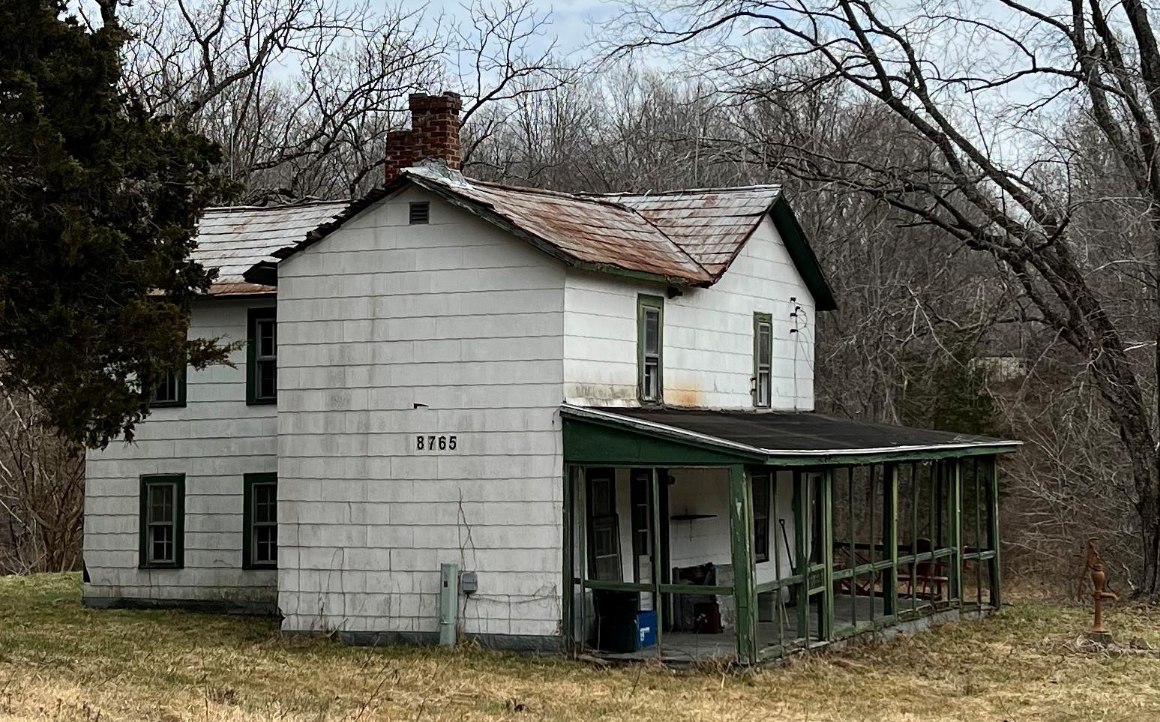
Figure 1: Exterior looking South East

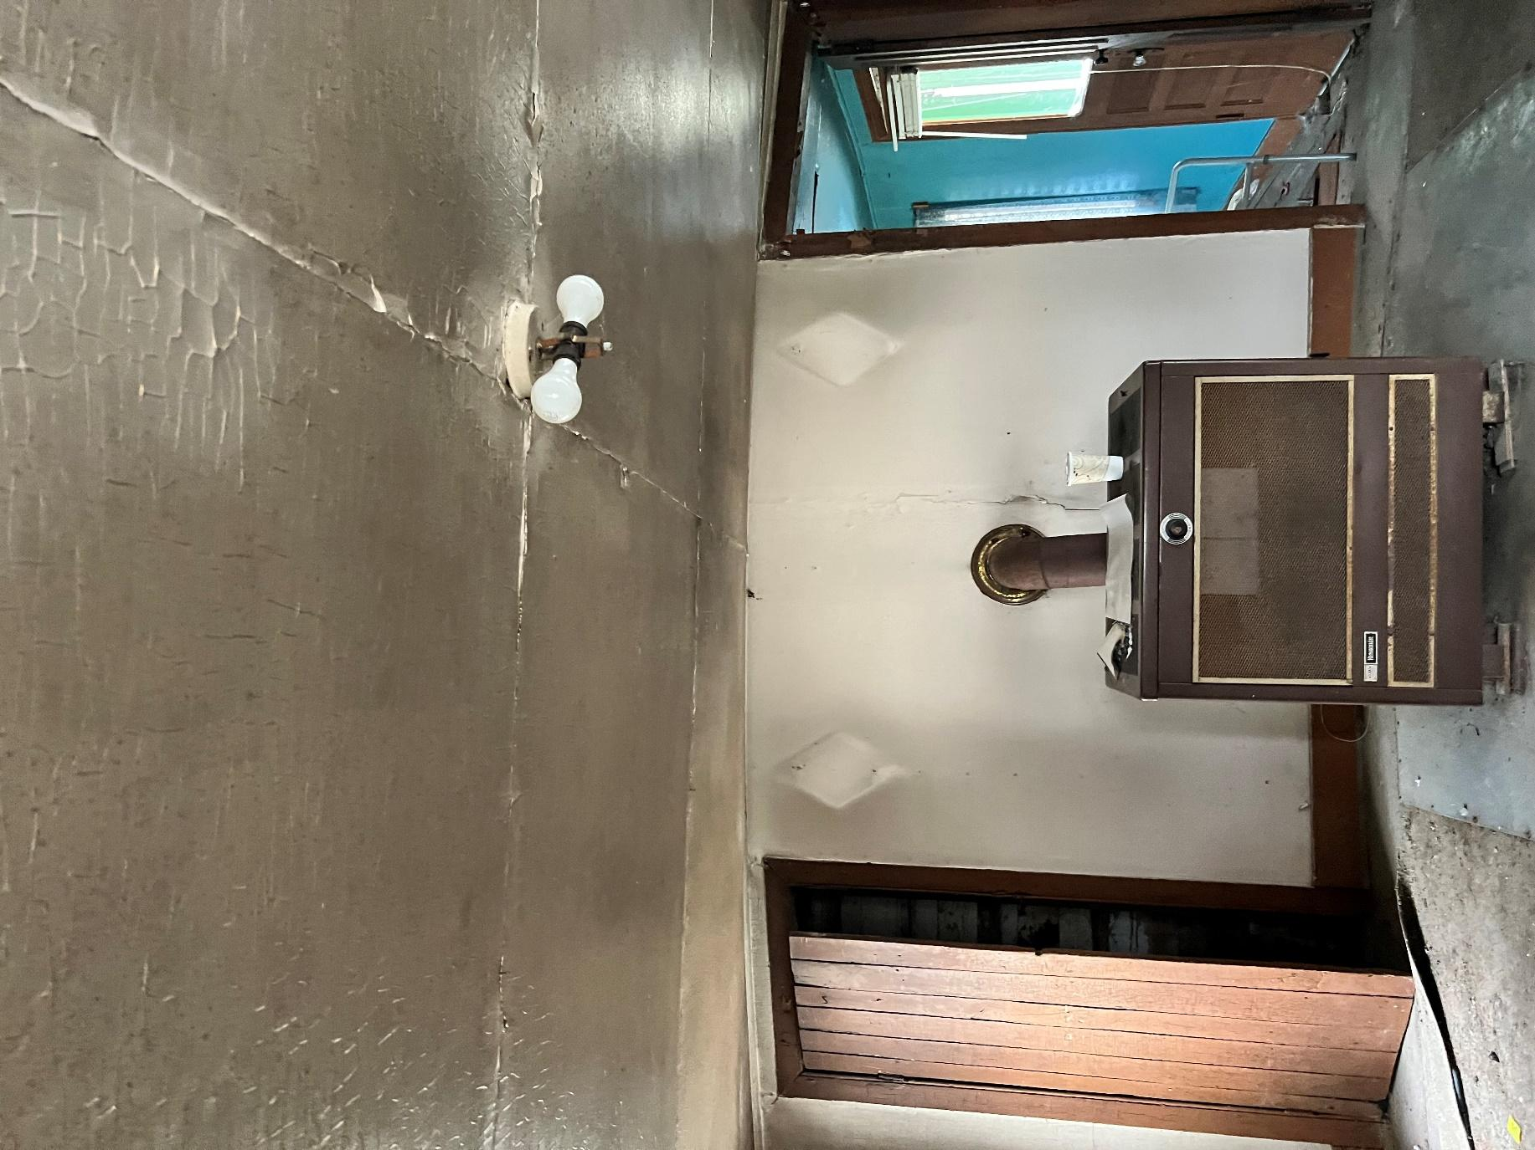
Figure 2: 1st floor Living Room
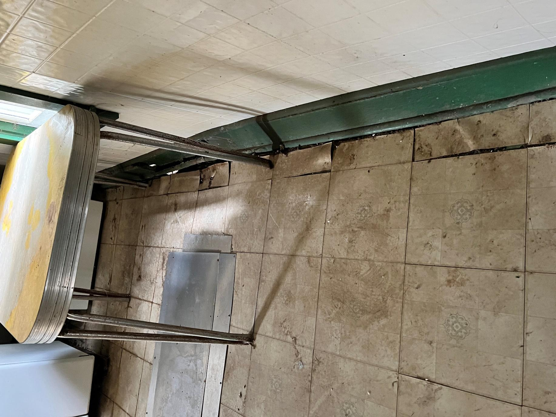
Figure 3: Kitchen
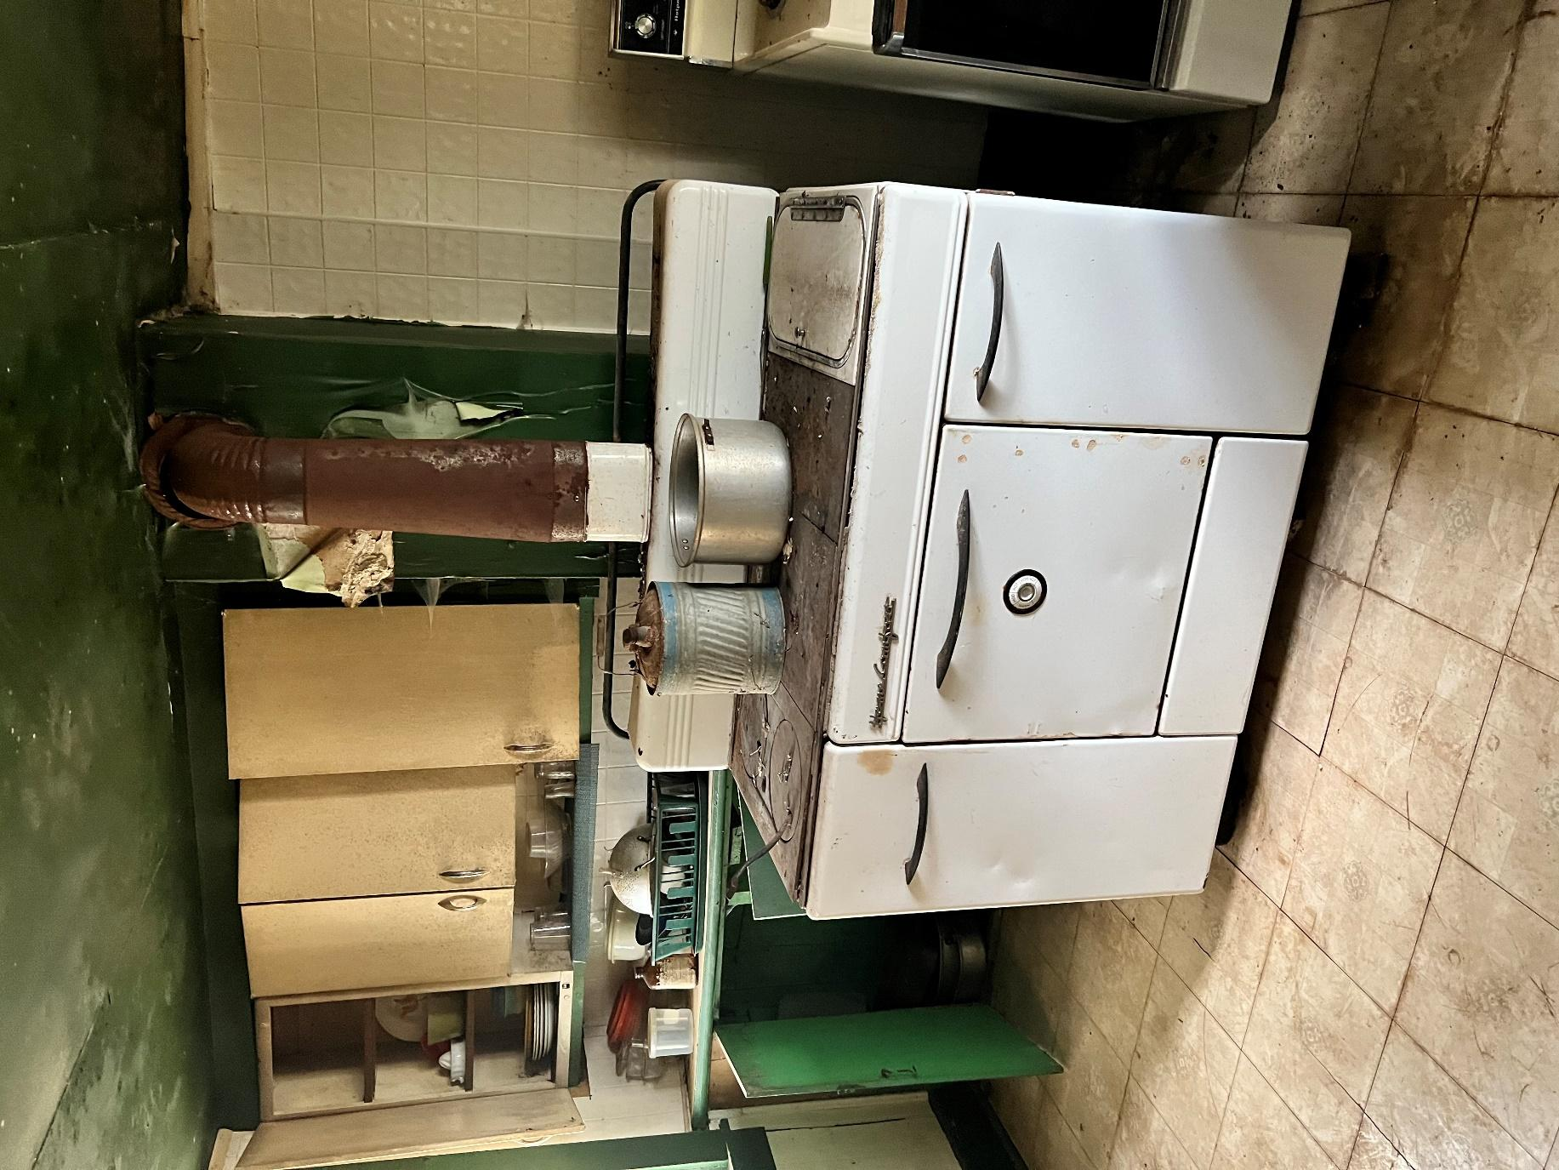
Figure 4: Kitchen
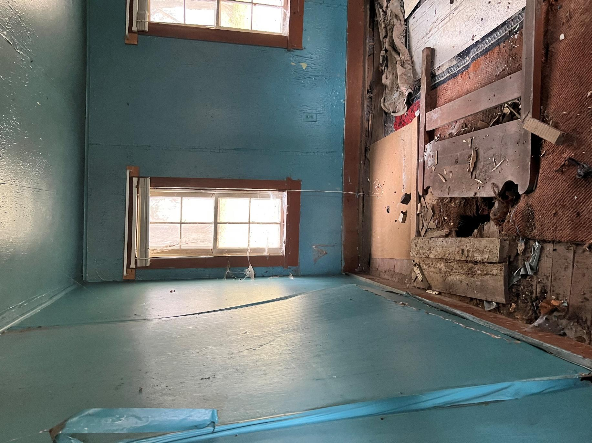
Figure 5: 1st floor den
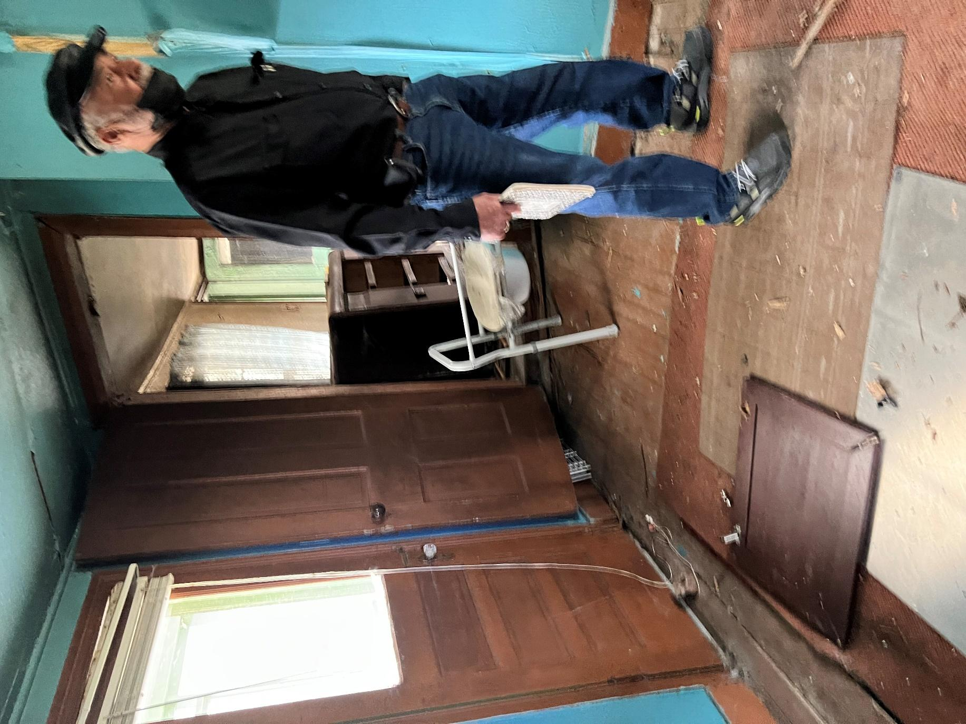
Figure 6: Den looking into Living Room
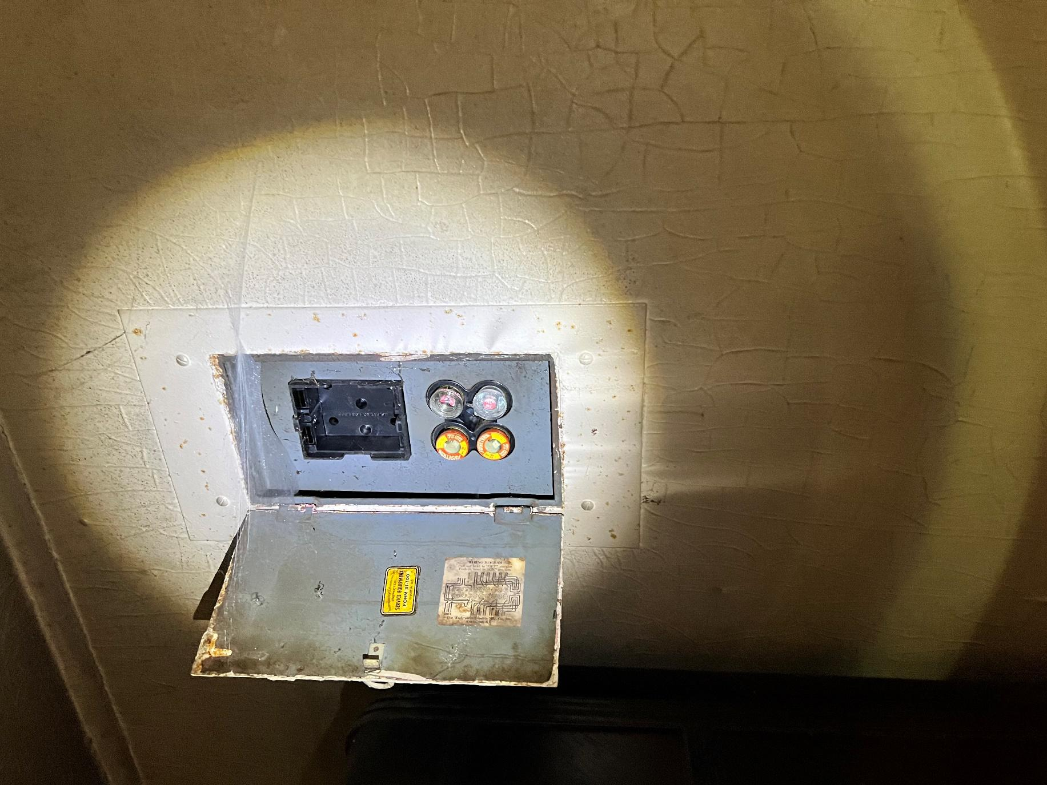
Figure 7: Defunct Electrical Panel
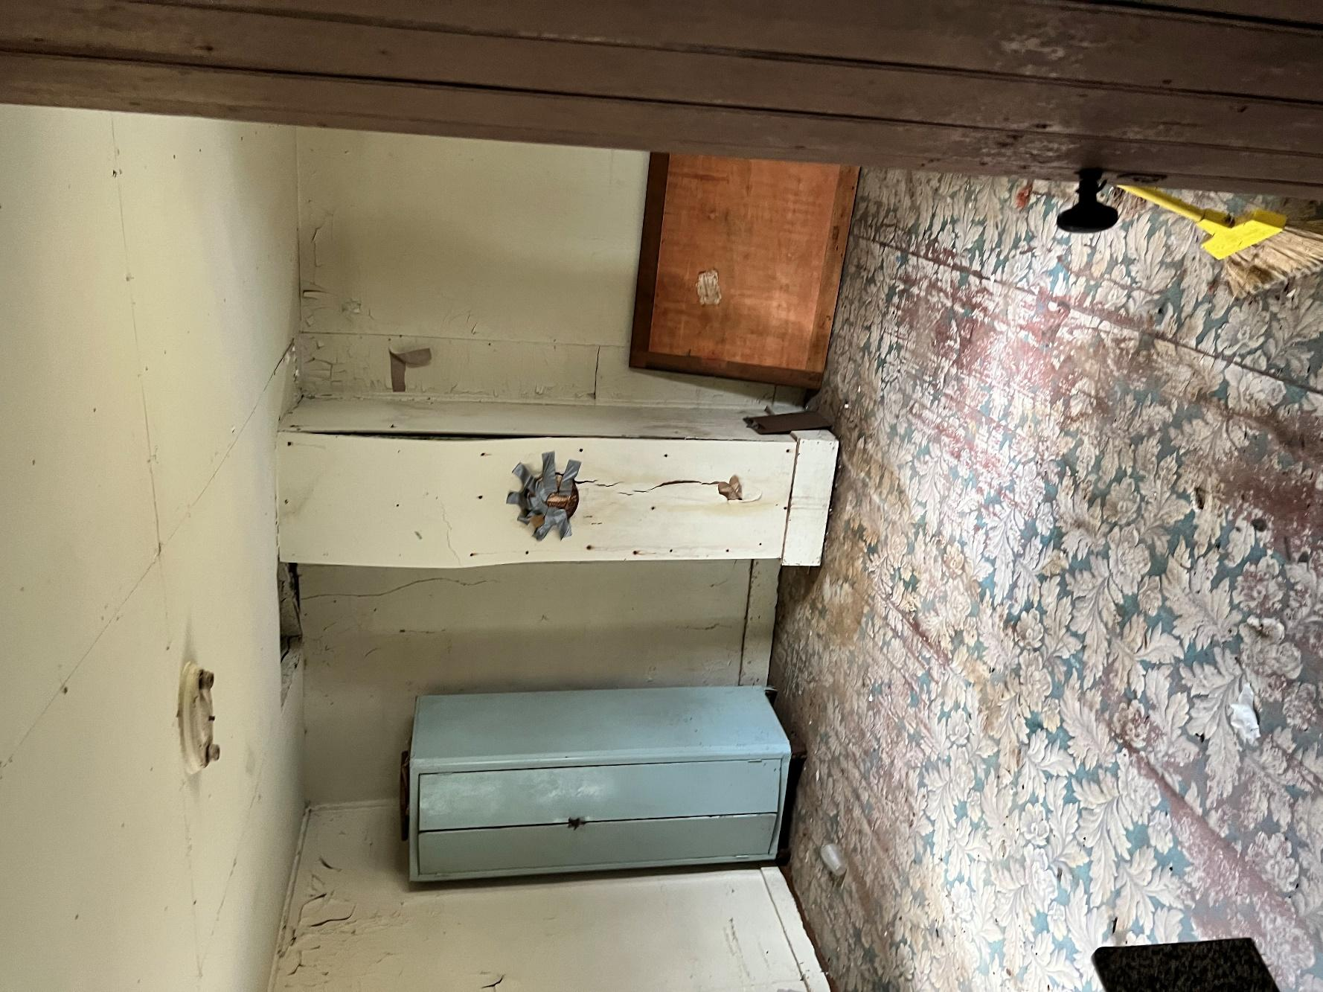
Figure 8: 2nd floor Master Bedroom (above Kitchen)
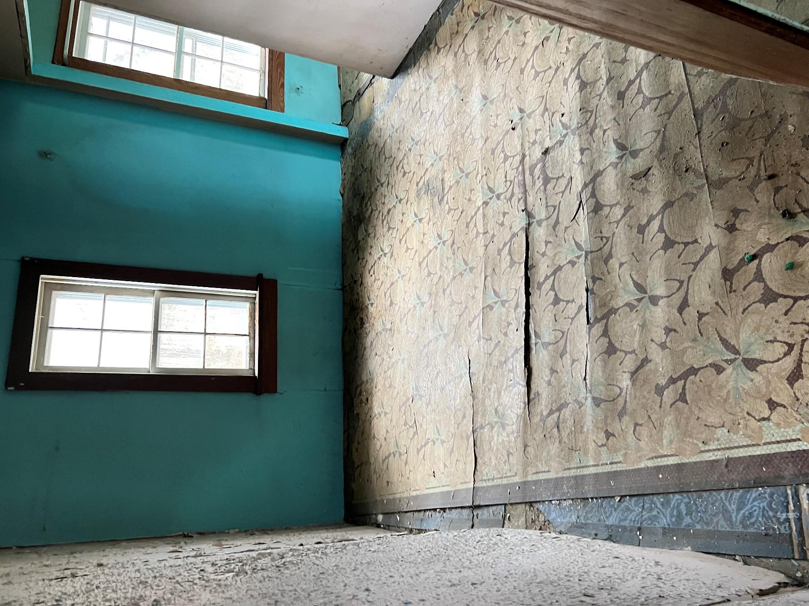
Figure 9: Bedroom 2 (above Living Room)
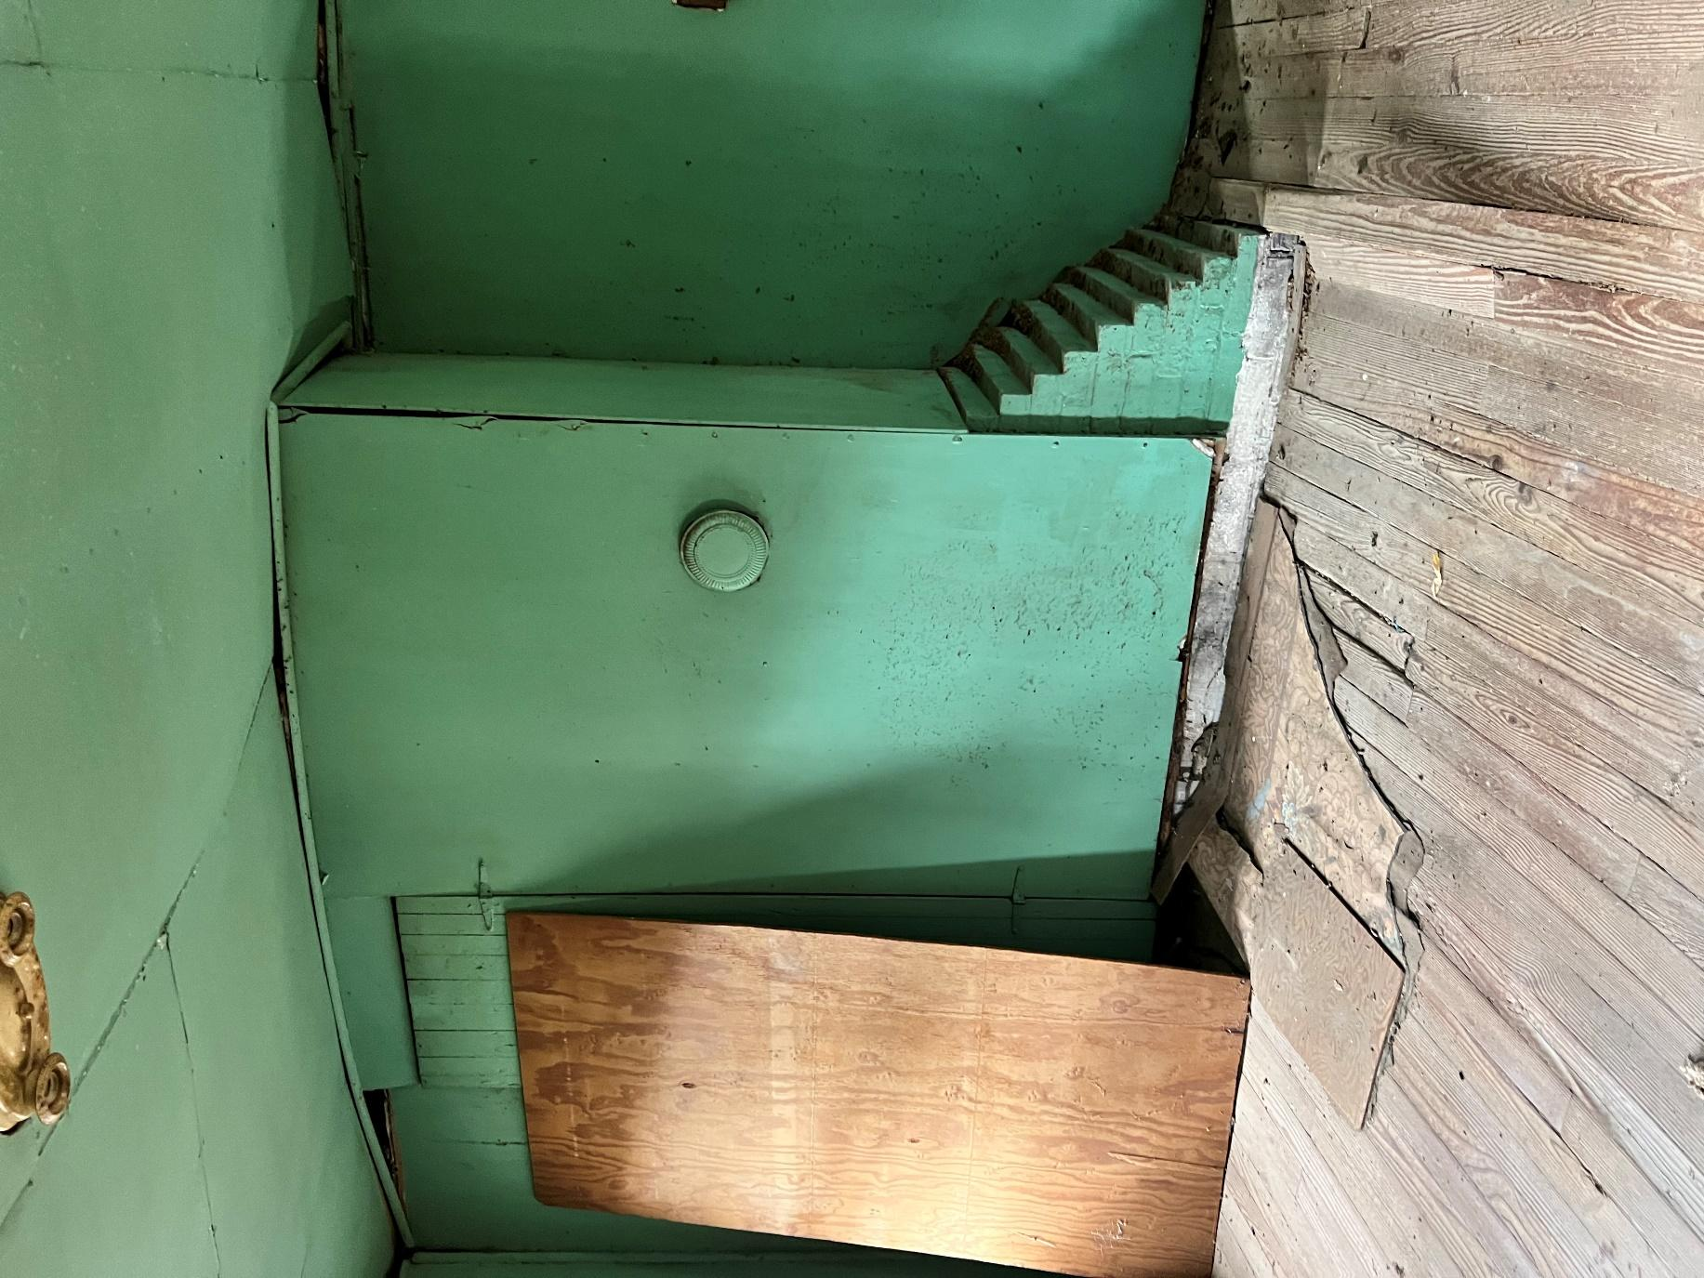
Figure 10: Bedroom 2 (above den)
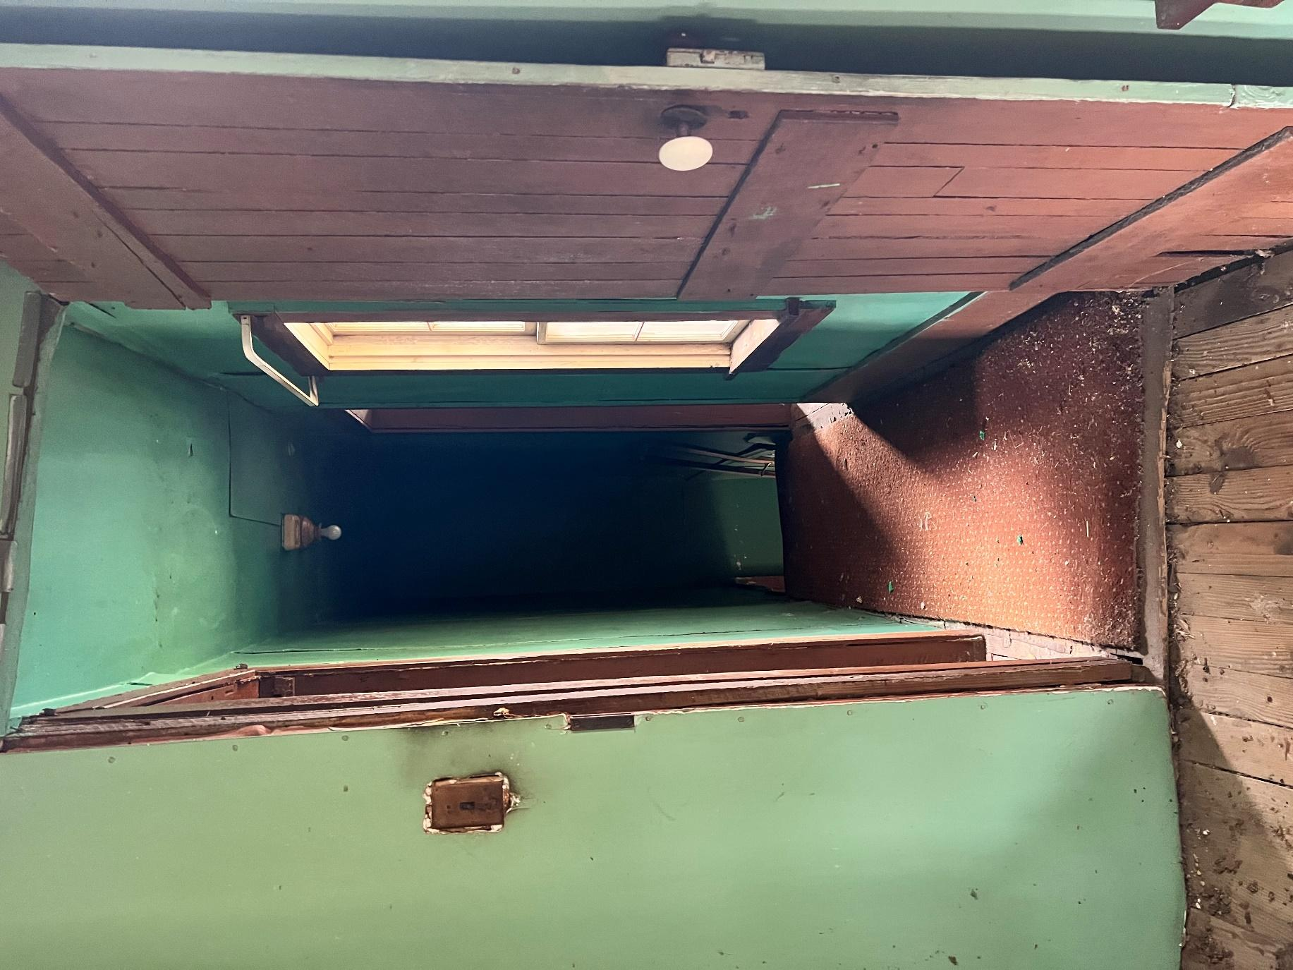
Figure 11: Hall looking from inside Bedroom 2 to stairs
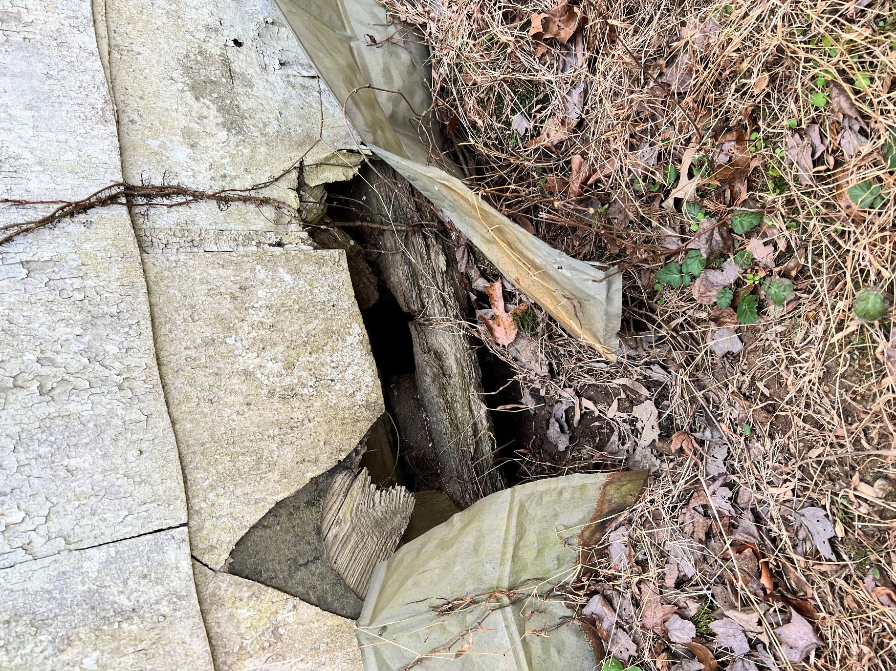
Figure 12: rotted sill plate on grade

SCOPE OF SERVICES
The successful offeror will provide a stabilization design plan as to how the stabilization would be achieved. The stabilization plan should be specific to include line items of work based upon labor cost and material cost for the stabilization. The offeror will follow the architect’s drawings and guidance from the owners during the stabilization phase. Specific areas of concern which are anticipated to be addressed with current funding:

The Scope of this work shall include SECTIONS 100, 101, 102 and 103 as indicated on the project Phasing Plan G1.1.
- Building Permits
- Termite Protection
- Temporary Shoring, Bracing and Sheeting Design & Shop Drawings w/ Maryland Engineers Stamp (as required). Structural Shoring Design shall be inclusive of items 101, 106, 110 and 111 as indicated on Phasing Plan G1.1 - The provisions of the Temporary shoring, Bracing and Sheeting Design shall be suitable for lifting the structure and the stabilization of the masonry chimneys as indicated in Phasing Plan G1.1.
- Temporary Shoring, Bracing and Sheeting. Shoring system to remain in place for the duration of project or as needed until the structure is adequately stable, secure, and lifted to the desired elevation. Contractor should anticipate the time frame to extend into portions of Phase Two as delineated on G1.1.
- Secure and Dry-in any wet areas or areas exposed during the stabilization process. Removal of Waste and Construction Debris.

All work must be executed in accordance with the Secretary of the Interior’s Standards for Rehabilitation. The contractor must be familiar with these Standards and must be willing to work with Working Out Wonders Foundation, Inc and MHT to resolve all unanticipated conditions.

Please provide a cost proposal using the attached financial proposal form and breakdown. Provide unit prices for additional work using the attached form. The Contractor may submit their standard quote sheet but must ALSO submit the filled out and signed cost proposal and unit prices forms.

The contract that results from this RFP will be a fixed-price contract.

PRE-PROPOSAL CONFERENCE / SITE VISIT

A site visit will be held at [10:00 a.m.] on [June 5, 2024] at 8765 Special Place, Nanjemoy, Maryland 20662. Attendance at the site visit is mandatory for firms wishing to submit a proposal. Proposals from firms not attending the pre-proposal site visit will be rejected.

TIMETABLE
The Contractor should expect to begin the project immediately upon notification of contract award (anticipated no later than first week of September 2024). It is anticipated that work should be substantially complete by December 31, 2024. Select demolition to be completed after consolation with selected Architect/Engineer.

QUALIFICATIONS
- The Contractor and any subcontractors must be licensed by the State of Maryland at the time of execution of this document.
- The Contractor and any subcontractors must demonstrate experience in working with historic buildings. Please use the attached qualifications form.
- The Contractor must demonstrate Contractor’s Professional Liability Insurance providing coverage in a principal amount of no less than $1,000,000 for any willful or negligent act or omission by the Contractor arising out of the performance of this Agreement. The Contractor will provide the owner with a certificate indicating that such insurance is in effect. Such insurance will add the Working Out Wonders Foundation, Inc. as additional insureds.
- The project will be partially funded through grants from the Maryland Historical Trust (MHT). The Contractor will be required to carefully document and submit project expenses with each request for payment. It may take 30-45 days or more to process requests for payment in order to allow for review and processing by MHT.

SELECTION CRITERIA
The selection of the Contractor will be based on the following factors, in order of descending importance:
1. Professional qualifications and experience.
2. Ability to complete the project within the time allotted.
3. Cost.

The contract will be awarded to the lowest proposal from a qualified firm which can complete the project within the time allotted. The Owners reserve the right to waive irregularities and to reject proposals.

RFP PACKAGE
List all items as part of the RFP package.

The RFP package consists of:
- This “Request for Proposals” document
- “Qualifications Statement” blank form
- “Financial Proposal” blank form
- “Conflict of Interest Affidavit and Disclosure” blank form

PROPOSAL SUBMISSION
Proposals must be received at wowfoundation@verizon.net or mail to Working Out Wonders Foundation, Inc., 17010 Old Marshall Hall Road, Accokeek, Md. 20607. No later than 5:00 p.m. on July 10, 2024.
Late proposals will not be considered.

A complete proposal submission consists of the following:
1. A completed and signed “Financial Proposal” form.
2. A completed “Qualifications Statement” with no more than [ten] pages of project-related supporting materials attached.
3. Resumes of up to three key project personnel; no more than [twelve] pages.
4. Completed “Conflict of Interest Affidavit and Disclosure” MUST be submitted with the proposal.
5. Copy of current license for contractor and any relevant subcontractors, MUST be submitted with the proposal.
6. Copy of current insurance certificate for contractor and any relevant subcontractors (preferred with the proposal submission but MUST be submitted before a contract is signed).
7. Contractor’s estimate of start date and time frame for project (may be included in cover letter).

Submit all proposal materials to: Working Out Wonders Foundation, Inc., at wowfoundation@verizon.net or mail to 17010 Old Marshall Hall Road, Accokeek, Md. 20607. Note: All proposals will be submitted electronically no later than 5:00 p.m. on July 10, 2024. Proposals will be acknowledged.

FAILURE TO INCLUDE ALL REQUIRED INFORMATION WILL RENDER THE PROPOSAL NON-RESPONSIVE.
NOTICES

Offerors should give specific attention to the identification of those portions of their proposals that they deem to be confidential, proprietary information or trade secrets and provide any justification why such materials, upon request, should not be disclosed by the State under the Access to Public Records Act, State Government Article, Title 10, Subtitle 6, Annotated Code of Maryland.

MBE / WBE firms are encouraged to respond to this solicitation (submit documentation).

The Consultant and any Subconsultants must be Equal Opportunity Employers.

By submitting a response to this solicitation, a vendor shall be deemed to represent that it is not in arrears in the payment of any obligation due and owing the State of Maryland, including the payment of taxes and employee benefits, and that it shall not become so in arrears during the term of the contract if selected for contract award.

CONTRACTOR FINANCIAL PROPOSAL FORM
REQUEST FOR PROPOSALS: Carroll Family Farmhouse & Cemetery Preservation Project

FIRM / TEAM NAME:

Description |  | Cost
The Scope of this work shall include SECTIONS 100, 101, 102 and 103 as indicated on the project Phasing Plan G1.1. Provide Itemized costs as follows:
Building Permits
Termite Protection
Temporary Shoring, Bracing and Sheeting Design & Shop Drawings w/ Maryland Engineers Stamp. Design shall be inclusive of items 101, 106 and 110 as indicated on Phasing Plan G1.1 - The provisions of the Temporary shoring, Bracing and Sheeting Design shall be suitable for lifting the structure and the stabilization of the masonry chimneys as indicated in Phasing Plan G1.1.
101. Temporary Shoring, Bracing and Sheeting. Shoring system to remain in place for the duration of project or as needed until the structure is adequately stable, secure, and lifted to the desired elevation.
Any Required Demolition
Secure and Dry-in any wet areas or areas exposed during stabilization process.
Removal of Waste and Construction Debris
Profit and Overhead
TOTAL

ADDENDA: Please fill in and initial to acknowledge receipt of RFP Addenda, if applicable.
Addendum Number and Date | Initials

Proposal submitted by representative hereby designated as project contact:
NAME:

TITLE & FIRM NAME:

ADDRESS:

PHONE:

E-MAIL:

FEDERAL EIN #

DATE:

SIGNATURE:

CONTRACTOR QUALIFICATIONS FORM

The undersigned certifies under oath the truth and correctness of all statements and of all answers to questions made hereinafter.

Project Identification: Carroll Family Farm & Cemetery Preservation Project

Company Name
Contact Name
Contact Title
Address, City, State, ZIP
Phone / Fax
Email
Website

1. | How many years has your organization been in business?
2. | How many years under your present name?
3. | What time periods under a previous business name? (List below)
 | Company Name |  |  |  |  |  | Dates
 | Company Name |  |  |  |  |  | Dates
 | Company Name |  |  |  |  |  | Dates
 | Company Name |  |  |  |  |  | Dates
4. | Is your organization licensed to do business in the State of Maryland? |  |  |  |  |  |  |  | ☐ Yes ☐ No
5. | Do you have a professional license in the State of Maryland? |  |  |  |  |  |  |  | ☐ Yes ☐ No
 | Type of license |  |  |  |  |  | License Number
 |  | Expiration date
 | Is your firm certified MBE in the State of Maryland? |  |  |  |  |  | ☐ Yes ☐ No
 | Have you in the previous five years, been denied a contract award on which you submitted the low bid/proposal in competitive bidding, or been refused pre-qualification? |  |  |  |  |  |  | ☐Yes ☐No
 | If yes, please explain:
 | List four or more projects executed by your firm within the past three years that were similar in nature and scope to this project, and were in compliance with the Secretary of the Interior's Standards (if applicable). Attach photographic documentation of these projects or refer us to your website. We may contact your references.
 | a. |  | Project Name
 |  |  | Project Address
 |  |  | When did you work on this project?
 |  |  | Client / Reference Name
 |  |  | Client / Reference Phone or Email
 |  |  | Web link if available
 | b. |  | Project Name
 |  |  | Project Address
 |  |  | When did you work on this project?
 |  |  | Client / Reference Name
 |  |  | Client / Reference Phone or Email
 |  |  | Web link if available
 | c. |  | Project Name
 |  |  | Project Address
 |  |  | When did you work on this project?
 |  |  | Client / Reference Name
 |  |  | Client / Reference Phone or Email
 |  |  | Web link if available
 | d. |  | Project Name
 |  |  | Project Address
 |  |  | When did you work on this project?
 |  |  | Client / Reference Name
 |  |  | Client / Reference Phone or Email
 |  |  | Web link if available
 | e. |  | Project Name
 |  |  | Project Address
 |  |  | When did you work on this project?
 |  |  | Client / Reference Name
 |  |  | Client / Reference Phone or Email
 |  |  | Web link if available
 | Provide names of key personnel to be involved in this project. Indicate the projects listed above with which they were involved. On attached sheets, give brief resumes of each person, describing specific experience and qualification that will indicate ability to perform work required on this project.
 | a. |  | Name
 |  |  | Specialty / Trade
 |  |  | Project Role
 |  |  | Years of experience
 |  |  | Years with this firm
 |  |  | Involved in projects listed above?
 | b. |  | Name
 |  |  | Specialty / Trade
 |  |  | Project Role
 |  |  | Years of experience
 |  |  | Years with this firm
 |  |  | Involved in projects listed above?
 | c. |  | Name
 |  |  | Specialty / Trade
 |  |  | Project Role
 |  |  | Years of experience
 |  |  | Years with this firm
 |  |  | Involved in projects listed above?
 | d. |  | Name
 |  |  | Specialty / Trade
 |  |  | Project Role
 |  |  | Years of experience
 |  |  | Years with this firm
 |  |  | Involved in projects listed above?
 | Please indicate which portions of the work you will subcontract and the names of the subcontractors. Please attach brief resumes of each subcontractor firm, describing specific experience and qualification that will indicate ability to perform work required on this project.
 | a. |  | Firm Name
 |  |  | Specialty / Trade
 |  |  | Address, City, State, Zip
 |  |  | Phone
 |  |  | Email
 |  |  | Website
 |  |  | Years in business
 |  |  | Involved in projects listed above?
 |  |  | MBE? |  | ☐ Yes ☐ No
 | b. |  | Firm Name
 |  |  | Specialty / Trade
 |  |  | Address, City, State, Zip
 |  |  | Phone
 |  |  | Email
 |  |  | Website
 |  |  | Years in business
 |  |  | Involved in projects listed above?
 |  |  | MBE? |  | ☐ Yes ☐ No
 | c. |  | Firm Name
 |  |  | Specialty / Trade
 |  |  | Address, City, State, Zip
 |  |  | Phone
 |  |  | Email
 |  |  | Website
 |  |  | Years in business
 |  |  | Involved in projects listed above?
 |  |  | MBE? |  | ☐ Yes ☐ No
 | d. |  | Firm Name
 |  |  | Specialty / Trade
 |  |  | Address, City, State, Zip
 |  |  | Phone
 |  |  | Email
 |  |  | Website
 |  |  | Years in business
 |  |  | Involved in projects listed above?
 |  |  | MBE? |  | ☐ Yes ☐ No

CONTRACTOR CONFLICT OF INTEREST AFFIDAVIT AND DISCLOSURE FORM
A. "Conflict of interest" means that because of other activities or relationships with other persons, a person is unable or potentially unable to render impartial assistance or advice to the State, or the person's objectivity in performing the contract work is or might be otherwise impaired, or a person has an unfair competitive advantage.
B. "Person" has the meaning stated in COMAR 21.01.02.01B(64) and includes a bidder, offeror, contractor, consultant, or subcontractor or subconsultant at any tier, and also includes an employee or agent of any of them if the employee or agent has or will have the authority to control or supervise all or a portion of the work for which a bid or offer is made.
C. The bidder or offeror warrants that, except as disclosed in §D, below, there are no relevant facts or circumstances now giving rise or which could, in the future, give rise to a conflict of interest.
D. The following facts or circumstances give rise or could in the future give rise to a conflict of interest (explain detail—attach additional sheets if necessary):
E. The bidder or offeror agrees that if an actual or potential conflict of interest arises after the date of this affidavit, the bidder or offeror shall immediately make a full disclosure in writing to the procurement officer of all relevant facts and circumstances. This disclosure shall include a description of actions which the bidder or offeror has taken and proposes to take to avoid, mitigate, or neutralize the actual or potential conflict of interest. If the contract has been awarded and performance of the contract has begun, the contractor shall continue performance until notified by the procurement officer of any contrary action to be taken.
I DO SOLEMNLY DECLARE AND AFFIRM UNDER THE PENALTIES OF PERJURY THAT THE CONTENTS OF THIS AFFIDAVIT ARE TRUE AND CORRECT TO THE BEST OF MY KNOWLEDGE, INFORMATION, AND BELIEF.
Date: ____________________
By: ______________________________________ (Authorized Representative and Affiant)

